Sanctioned By:

City of Davenport’s

Grills Gone Wild

Hosted By:

COOK TEAM APPLICATION FORM

DEADLINE TO APPLY: Friday February 2nd ,2024.

For office use only: $_______________ Type: ____________ Date: ______________ Initials: _____________

Thank you for your interest in competing at the City of Davenport’s Grills Gone Wild.

**Any team’s Head Cook/Pitmaster competing in a sanctioned contest must be a KCBS member in good standing!**

We’ll see you in February!

2024 City of Davenport Grills Gone Wild

Friday, February 9th and Saturday, February 10th

**Tom Fellows Community Center**

**207 N Blvd. West Davenport FL 33837**

PLEASE MAKE CHECK PAYABLE AND SUBMIT COMPLETED FORM TO:

The City of Davenport

1 South Allapaha Ave., Davenport, FL. 33836

Phone: 863-588-1130

Email: [Dbleiweiss@mydavenport.org](mailto:Dbleiweiss@mydavenport.org)

Team Name: __________________________________ Division:  Professional  Backyard

Head Cook: ___________________________________ KCBS Member Number: ______________

Address: ____________________________________________________________________

Phone: ______________________ Email: __________________________________________

Amp needed: NO CHANGES/NO EXCEPTION 20-amp 30-amp 50-amp (additional $50.00)

Cook space requested: __________________________________________________________

Vending:  Yes  No Items Vending: ____________________________________________

NO CASH SALES. Food vendors shall accept “Wild Money” only. Vendor will receive 80% of gross sales, organizer will retain 20%. No alcohol sales.

NO POWER will be provided on Thursday February 8th.

 PROFESSIONAL 20’x40’ $350.00  ADDITIONAL SPACE 20’x20’ $100.00  PRIVATE PORT-O-LET $75.00

 BACKYARD 20’x20’ $200.00

TOTAL: $______________

PLEASE READ: Spaces will be assigned in the order in which FEES are received. Due to fire and safety regulation your vehicles, trailers and equipment MUST fit inside allotted space. NO EXCEPTION. Water hook-ups are available, but you must bring a 100’ hose.

Signature: __________________________________________________________ Date: ______________________________

Your signature indicates that you have read and agree to the “Waiver of Liability” (below) and the “Rules and Regulations” as provided by The City of Davenport and the KCBS in cook information packets and online. Event held rain or shine. Entry fees are non-refundable. One portable fire extinguisher with a rating of not less than 2-A: 10-B: C required if any type of ignition source is present at your cook site. The City of Davenport reserves the right to reject any applications.

APPLICATION AGREEMENT: BY RETURNING THE COOK TEAM APPLICATION FORM, I AGREE TO ABIDE BY THE RULES AND REGULATIONS OF THE CITY OF DAVENPORT and rules, guidelines and laws established by the City of Davenport, Fire Codes (mailed upon request) and The Kansas City Barbeque Society.

**WAIVER OF LIABILITY:** In consideration of your accepting this entry, I, the undersigned, intending to be legally bound, hereby, for myself, my heirs, my executors and administrators, waive and release any and all rights and claims for damages I may have against the City of Davenport, The Kansas City Barbeque Society and their agents, sponsors, successors and assigns for any and all injuries suffered by me at this event. Further, I hereby grant full permission to the City of Davenport and their agents, sponsors, successors and assigns to use my photographs, name, likeness, recording, videotapes or any other record of this event for the legitimate purpose.

**Thursday, February 8th: Set Up** 8am – 8pm **Quiet Time**: 11 pm -6 am

**Friday, February 9th: Set up** 8 am – 12 pm **Meat Inspection**: 12 pm – 5 pm **Cook’s Meeting**: 5 pm **Quiet Time**: 11 pm -6 am

**Saturday, February 10th: Turn In**: Chicken 11 am | Ribs 12 pm | Pork 1 pm | Brisket 2 pm **Awards Ceremony**: 5 pm

PROFESSIONAL DIVISION OVERALL COMPETITION

Grand Champion Trophy **$3,000**

Reserve Champion Trophy **$1,500**

3rd Place Overall Trophy **$600**

4th Place Overall Trophy **$300**

5th Place Overall Trophy **$200**

6th Place Overall Trophy **$100**

7th Place Overall Trophy **$100**

8th Place Overall Trophy **$75**

9th Place Overall Trophy **$75**

10th Place Overall Trophy **$50**

Each Category Competition

1st Place Trophy **$400**

2nd Place Trophy **$300**

3rd Place Trophy **$175**

4th Place Trophy **$150**

5th Place Trophy **$125**

6th Place **$100**

7th Place **$75**

8th Place **$75**

9th Place **$50**

10th Place **$50**

BACKYARD DIVISON OVERALL COMPETITION

Grand Champion Trophy **$600**

Reserve Champion Trophy **$300**

3rd Place Overall Trophy **$200**

4th Place Overall Trophy **$125**

5th Place Overall Trophy **$50**

Each Category Competition

1st Place Trophy **$50**

2nd Place **$50**

3rd Place  **$50**

4th Place **$50**

5th Place **$50**

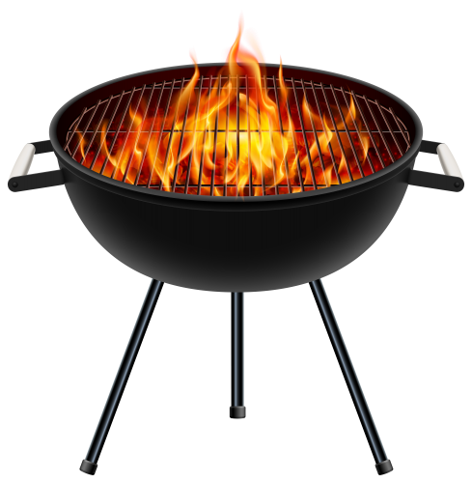

* **Any team’s Head Cook/Pitmaster competing in a sanctioned contest must be a KCBS member in good standing**
* The team/vendor retains 80% and the City receives 20%.
* Any exchange of currency will result in that team being disqualified for any prize money or awards.
* All teams who are vending must secure a Temporary Food Service License. See Guide to Temporary Food Service Events for more information (myfloridalicense.com/dbpr/HR/forms/documents/5030_034.pdf).
* Vending is permitted on Friday & Saturday. Backyard & Professional teams must register in all (4) categories (chicken, pork, rib & brisket) to vend. No vending fee is required.
* All fees MUST accompany application and are nonrefundable.
* Space will be assigned at the discretion of the City of Davenport staff.
* Power for Thursday arrival if needed/wanted will be an additional $75.00.
* **You must decide your power and space needs prior to the event. No last minute changes!**
* Setup must be completed by 5:00 PM Friday.
* Ice will be available to purchase for $5/20 lb. bag.
* Dessert competition. Winner receives $50 cash. Contact us for forms & guidelines.
* Sauce competition will be in the following category: Sweet. Winner receives $50 cash. Contact us for forms & guidelines.
* Entry deadline: Intentions by February 2nd, 2024, FEES ARE NON-REFUNDABLE. Application submittal does not guarantee acceptance to the contest. Entry fee must accompany the entry form. Fees must be received by February 2nd, 2024. You will need to download, complete and mail in the registration form along with payment.