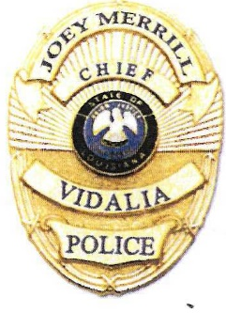
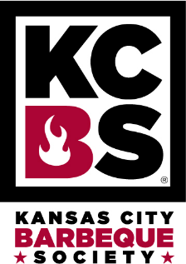
VPD
Back The Blue BBQ
__________________________________________________________________________________________________
KCBS Louisiana State Championship
October 23th – 24Th, 2026

CASH POT OVER
$10,000.00
RESERVE YOUR COOK TEAM/CAMPSITES AT
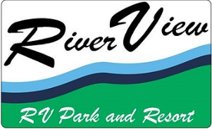
Riverview RV Park 318-336-1400
*Campsites are not included in Competition Registration*
Craft & Food Vendors!
For More Information Contact Georganna Berry or Andrea Foster
At 318-336-5254 gberry@vidalialapd.com afoster@vidalialapd.com

CAR SHOW
Antique Car (under year 2000)
Antique Car 1st, 2nd, and 3rd place
Antique Truck 1st, 2nd, and 3rd place
Race Car/ Rat Rod 1st , 2nd and 3rd place
NEW MODELS (OVER YEAR 2000) 1ST, 2ND,3rd, place
Motorcycle Best In Show
Best of Show Overall
Registration $20.00 Day of Event
For more information call 318 336 5254

