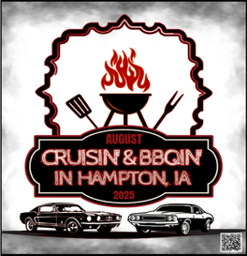
Cruisin’ & BBQin’ in Hampton, IA
KCBS Masters Series Event
July 31-August 1, 2026

TEAM NAME: KCBS #:

HEAD COOK NAME:

ADDRESS:

CITY: STATE: ZIP:

EMAIL: PHONE: ______________________________________________________________________
Registration Fee $325 No Refunds after June 30

Space Sizes are approximately 20 X 40. Space Size You Need _________
Sign up early We will do our best to accommodate your space size. First signed up, first served. Sorry no electricity.

Site Location – 20 5th Street NW, Hampton, IA. Enter from Hwy 3 East or West, turn North, behind Family Dollar.

Activities in the area. Bring the family:
Local Pool (Indoor and Outdoor), Theatre, Bike/Walking Trails, Fishing, Historical Sites
Two Hotels within walking distance.

Watch our Facebook page Cruising & BBQin - in Hampton, IA

Acknowledgement and Release
By signing below, I agree that I will assume all risks that arise from my participation. I also hereby waive any claims against Access Inc. and its co-sponsors for any injuries or loss that arise from our participation.
Further, I grant full permission to the event organizers, promoters and sponsors or any agent authorized by them, to use any photographs, videos, recordings or any other record of this event for any legitimate purpose. I acknowledge that I have read, understand and agree to all the Rules and Regulations of which are incorporated to this agreement by reference
Signature ___________________________________________________Date ________________

Send Registration to: Direct Questions To:
Barb Furman Charlane Janssen
502 - 10th Street SE cprallejanssen@gmail.com
Hampton, IA 50441 515-689-9770

